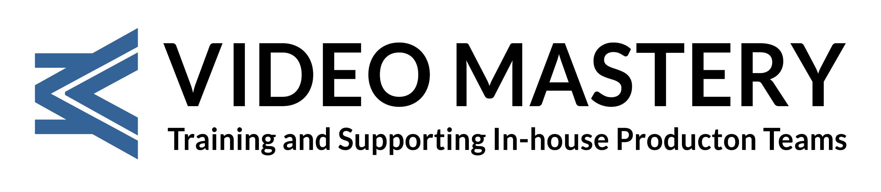

RELEASE FORM

Production Date(s):

Program Title (working title):

Participant’s Name:

Producer/Production Entity: (“Producer”)

Production Location:

I hereby authorize “Producer” to record and edit into the Program and related materials my name, likeness, image, voice and participation in and performance on film, tape or otherwise for use in the above “Program” or parts thereof (the “Recordings”). I agree that the “Program” may be edited and otherwise altered at the sole discretion of the “Producer” and used in whole or in part for any and all broadcasting, non-broadcasting, audio/visual, and/or exhibition purposes in any manner or media, in perpetuity, throughout the world.
I understand that there will be a total buy-out fee of £______ for my appearance, and reasonable travel expenses will be paid.
The “Producer” may use and authorize others to use all or parts of the “Recordings”. The “Producer”, its successors and assigns shall own all right, title and interest, including copyright, in and to the “Program”, including the “Recordings”, to be used and disposed of without limitation as “Producer” shall in its sole discretion determine.

Signature of Talent:

Address: Post Code:

Date: Phone:

Name of Producer:

Signature of Producer:

Date:

© Copyright, 2025, Video Mastery Ltd. All rights reserved.

